**RESTful API design**

## Resources, hierarchies and relations:

|  |  |  |
| --- | --- | --- |
| Resource Name | Resource url | Resource Description |
| Currency | http://127.0.0.1:5000/updown/api/currency/{currency_id} | Manipulate a currency PUT, DELETE using it is id |
| Currencies | http://127.0.0.1:5000/updown/api/currencies/ | GET list of all currencies or add new currency |
| User | http://127.0.0.1:5000/updown/api/user/{user_id} | Manipulate a user PUT, DELETE using it is id |
| Users | http://127.0.0.1:5000/updown/api/users/ | GET list of all users or add new user |
| Choice | http://127.0.0.1:5000/updown/api/choice/{choice_id} | Manipulate choices parameter based on user preferences of currencies exchange (DELETE,GET) |
| Choices | http://127.0.0.1:5000/updown/api/choices/ | List a user choices of currencies exchange preferences, add new entry (POST, GET) |
| Exchange | http://127.0.0.1:5000/updown/api/exchange/{exchange_id} | DELETE,GET a currency exchange entry using its id |
| Exchanges | http://127.0.0.1:5000/updown/api/exchange/?currency_from={ currency_from }&currency_to={ currency_to }&date={date_from}&date={date_to}&rate={rate}/ | GET list of currencies’ exchanges rates, the selection based on the currencies and the date. Add new exchange rate |

A tree diagram showing the **URL hierarchy:**

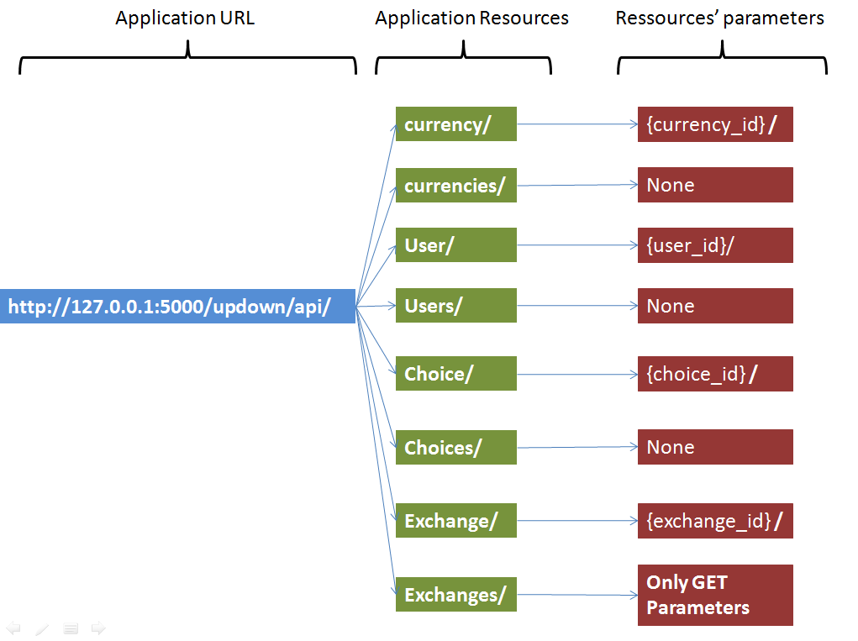

**A state diagram of your application:**

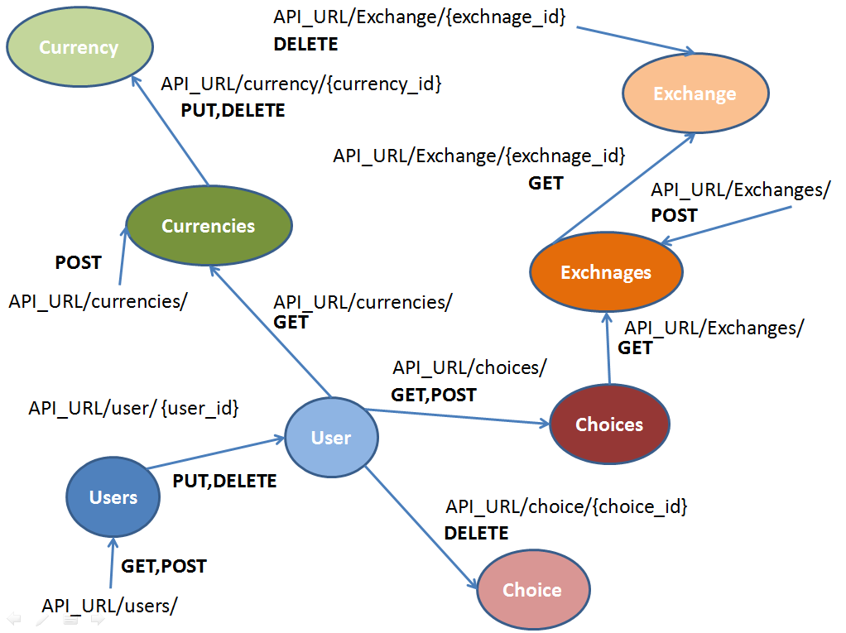

### Uniform interface :

|  |  |  |  |  |
| --- | --- | --- | --- | --- |
| Ressource Name | GET | POST | PUT | DELETE |
| User | Get the username, password, fullname of the user with the parameter user_id | None | Update the user with the parameter user_id. It updates the user password and fullname | Delete the user with the parameter user_id. |
| Users | Get all users from the DB. It Gets the users’ fullnames, usernames, and passwords | Add new user to the DB. It generates a new user_id and give it a username, fullname and password from the json sent in the request body. | None | None |
| Currency | None | None | Update currency_code and currency_name of the currency with the currency_id specified in the url | Delete the currency with the id currency_id |
| Currencies | Get all currencies. It gets the currency_id, currency_code and currency_name of each currency. | Create new currency with an auto generated currency_id. The currency_code and currency_name are specified in the body of the POST request | None | None |
| Choice | Get the choice of the user based on username, date_from, date_to, currecy_from and currency_to specified as a GET parameters | None | None | Delete the user choice based on the choice_id in the resource link |
| Choices | GET user all choices, based on user_id. It Gets, choice_id, currency_from, currency_to, date_from, date_to. | Create a new choice with an auto generate id. The user_id, currency_from, currency_to, date_from, date_to are sent in the request body | None | None |
| Exchange | Get an exchange rate using an exchange_id provided in the url. It gets the currency_from, currency_to, exact_date and rate. | None | None | Delete the exchange rate with the id exchange_id |
| Exchanges | GET list of exchanges based on the GET parameters : date_from, date_to, currency_from, currency_to.  It gets each exchange : exchange_id, currency_from, currency_to, exact_date and rate | Create a new exchange entry based on the parameters : currency_from, currency_to, exact_date and rate provided in the request body | None | None |

Sequence diagrams : using tool <https://www.websequencediagrams.com/>

User GET:

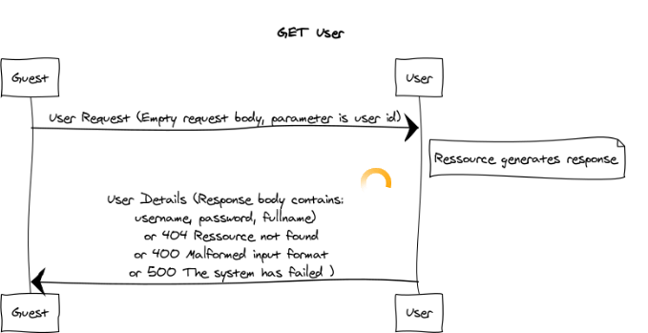

User PUT:

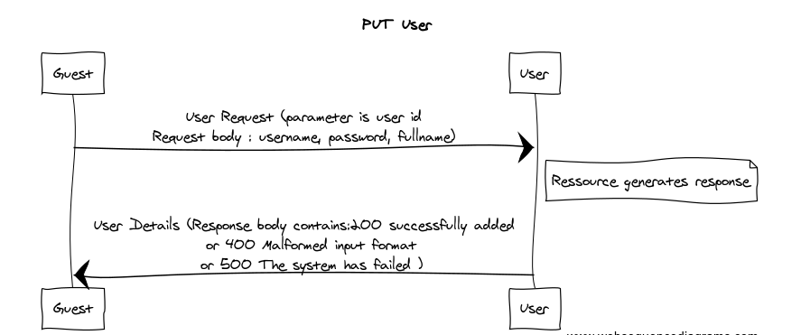

User DELETE:

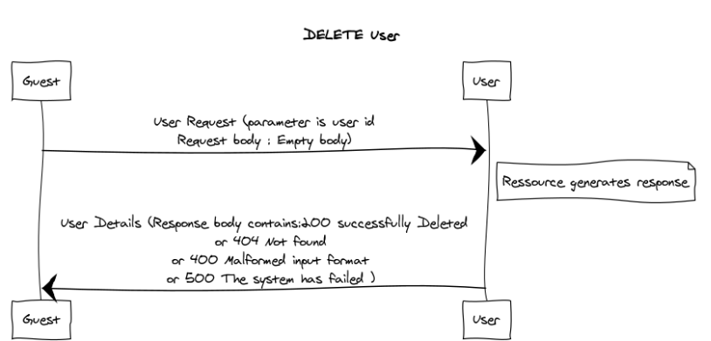

Users

GET

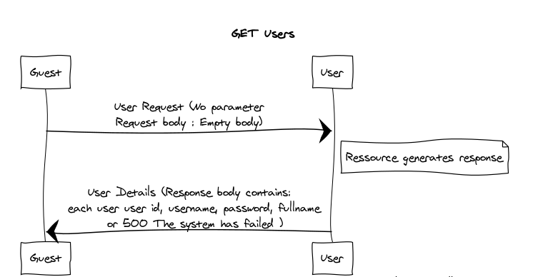

POST

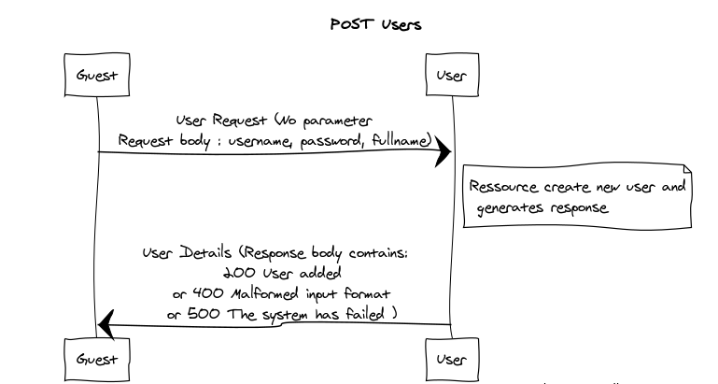

Currency

PUT

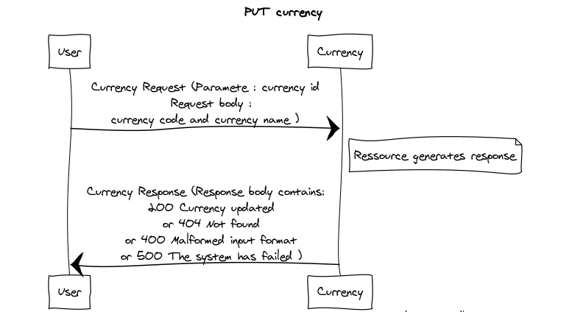

DELETE

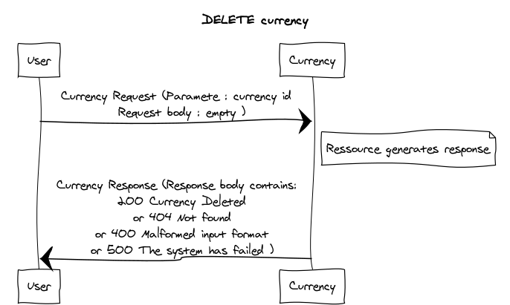

Currencies

GET

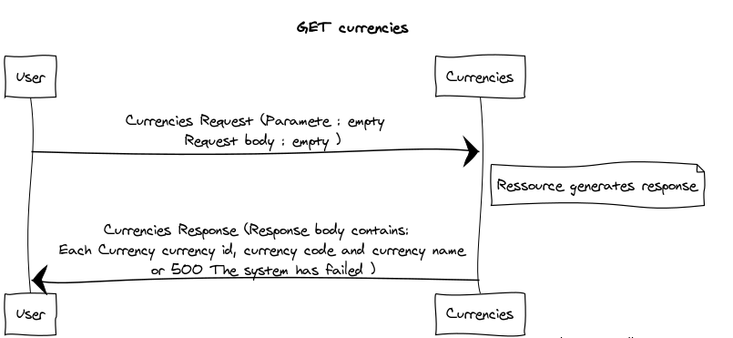

POST

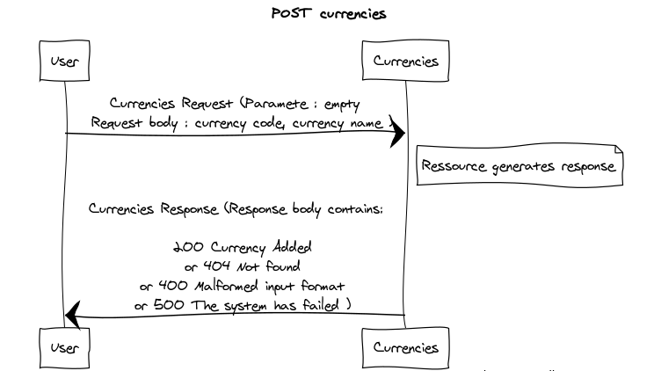

Choice

GET

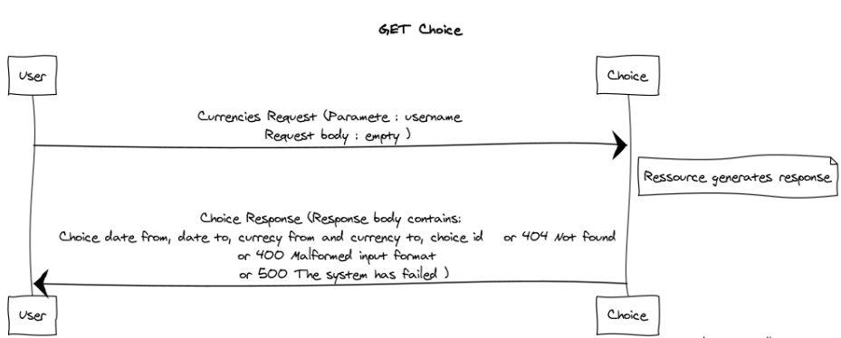

DELETE

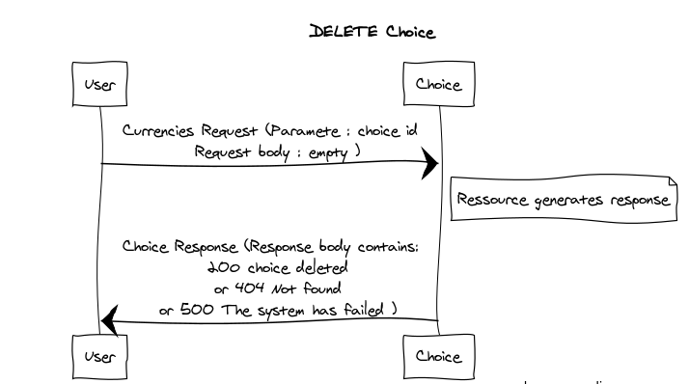

Choices

GET

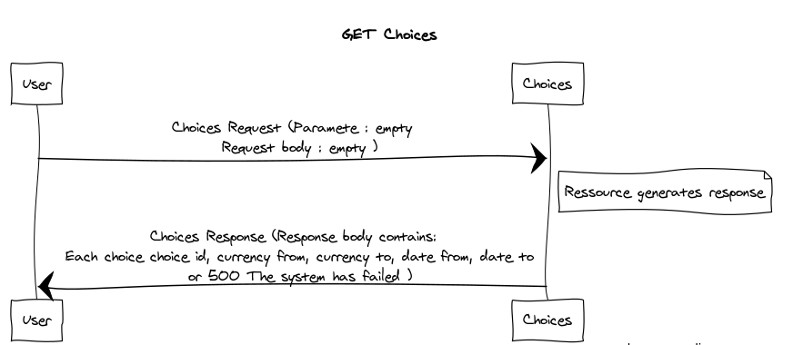

POST

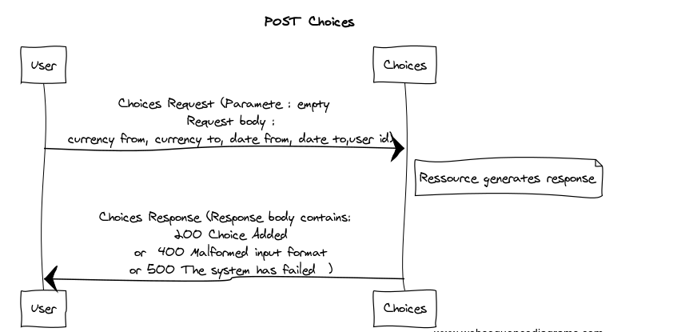

Exchange

GET

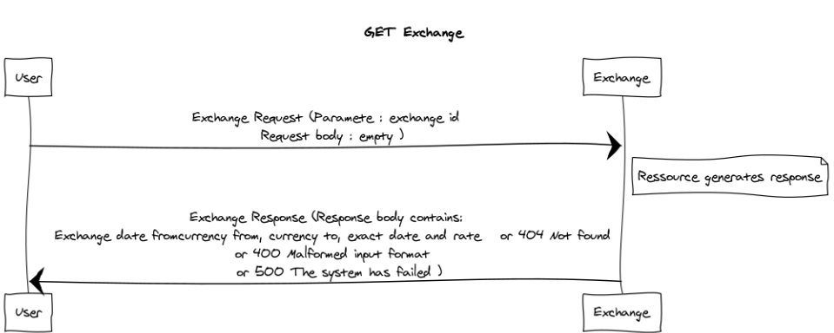

DELETE

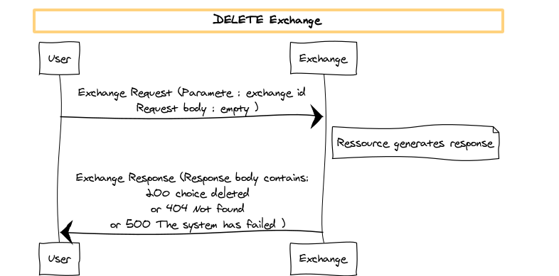

Exchange

GET

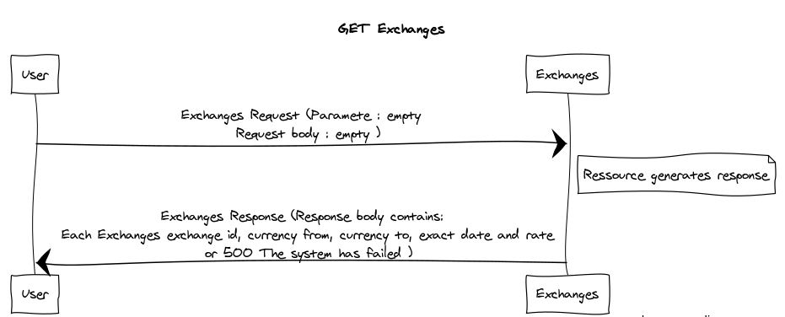

POST

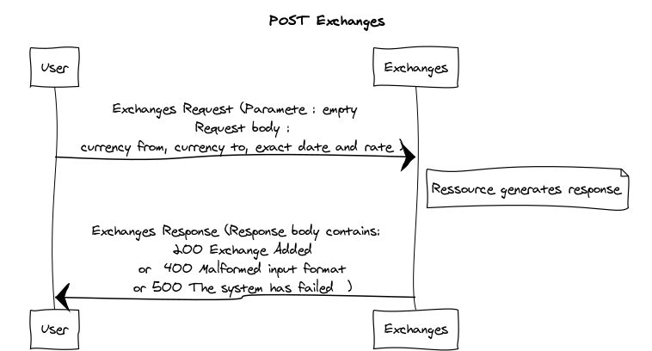

### Hypermedia API : (Documentation)

PWP_forum_app_complete.apib contains the blueprint. It ill be uploaded on the apiary.io for student url

## REST conformance

This API respects the ROA properties :

1. Addressability : Each of the resources has its unique url address (User, Users, Exchange, Exchanges, Currency, Currencies, Choice, Choices )
2. Each resource has its uniform interface according to the needs (GET, POST, DELETE, UPDATE)
3. Each resource is stateless where its does not change
4. Connectedness where resources link to each others.

Like :

Users links to each User, Choices

Currencies link to each Currency

Choices link to Choice

and Choice link to Exchanges